741204401723
БАЛГАБАЕВА Рахима Наримбетовна,
№31 Абай атындағы жалпы білім беретін мектебінің ағылшын тілі пәні мұғалімі.
Түркістан қаласы

UNIT REVISION

Learning objectives(s) that this lesson is contributing to: | 3.6.3.1 pronounce familiar words and short phrases intelligibly when reading aloud  3.6.3.1 recognise, identify and sound with support a limited range of familiar words in simple sentences  3.6.3.1 read and follow with limited support familiar instructions for classroom activities
Lessonobjectives: | All learners will be able to: know the new vocabulary  Most learners will be able to:answer the questions  Some learners will be able to:make and measure
Value links | Respect each other  Be friendly

Part of the lesson/Time | Teacher’s activity |  | Student’s activity | Assessment | Resources
Beginning of the lesson  Pre-learning  «Brainstorming» method  5 min. | Greeting students: Good afternoon,pupils! How are you?  Who is on duty today? Who is absent?  What day is it today? What is the weathervlike today?  Revision of previous lessons materials with the help of the teacher. Home task was to learn musical instruments.  Differentiation:  «Flashcards» T asks different cards quickly and ask name what do they see on the card.  After that T introduces the aim and theme of the lesson. |  | Ss give their possible answers.  Revise vocabulary connected with previous module  Aim:Revise the previous lessons material. Efficiency:Ss refresh their mind before starting new theme.  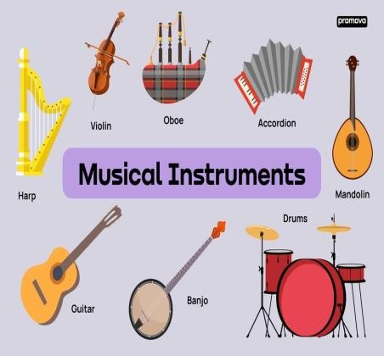 | Descriptor:  -remember the words  - can name them.  Total: 2point | Whiteboard Flashcards  Pupils Book
Middle of the lesson Presentation part.  8 min. | «Visual aids» method. Refer the pupils to the picture and ask: Where is she? Read the instruction and explain the activity.  Sing a song together with students.  Aim: to present and activate the new language Differentiation:“Verbal support” |  | 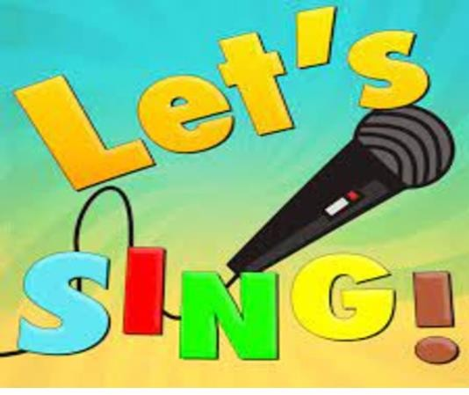 | Descriptor:  -can pronounce correctly  -give correct answers  Total: 2point | Whiteboard Pupils  Book  Poster
12 min. | Read the instruction and explain the activity.  Refer the pupils to the |  | Exercise 2  Learn the musical instrument by clap sound. | Descriptor:  - pronounce correctly | Whiteboard Pupils  Book
 | sentences at the end of Ex2 and read them out loud. Allow students learn musical instruments by clap sound.  Aim:present and consolidate vocabulary |  |  | -correct answer  Total: 2point | Poster
10 min. | Explain the activity.  Aim:Develop their motor skills Efficiency: Develop their motor skills |  | 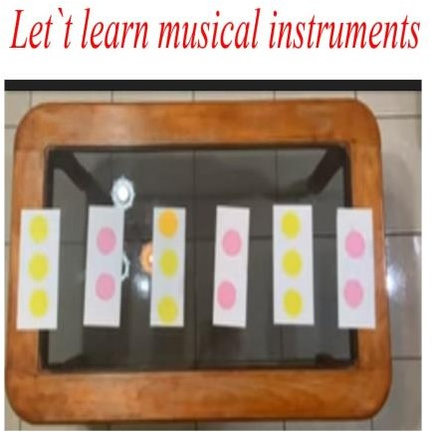 | Descriptor:  -make a measure  Total: 2point | Whiteboard Pupils  Book  Poster
 | «Visual aids» method. Refer the pupils to the pictures and ask:Do you know how to play dombra? Do you like musical instruments? |  |  | T praise active Ss with phrases such as: “Good job! Well done!”
5 min | Look at the pictures and describe them. Use vocabulary connected with musical instruments. AND USE GRAMMAR I CAN AND CAN'T WHEN YOU ARE MAKING SENTENCES.  Exercise 2: Complete the text my day.  Exercise 3: Make a dialogue to the theme My favourite characters  by acting with pictures.Studens will |  | 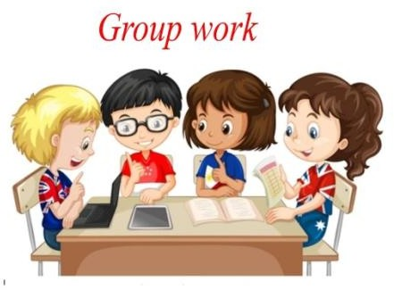  Work with pictures. Describing | Descriptor:  -draw the picture  -identify types of colours 2 point | Whiteboard Pupils  Book  Poster.
 | develop their speaking and communication skills. Also they will learn different characters  Aim:practice vocabulary Efficiency:to develop their speaking skills | 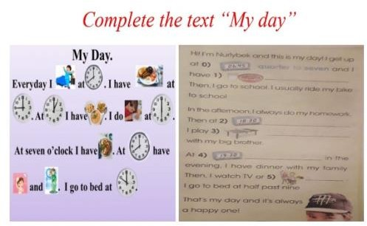  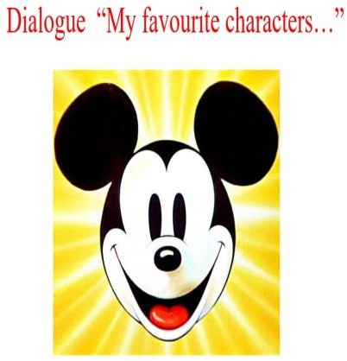
End of the lesson  Reflection  5 min. | Traffic light method is used to find out was the lesson clear or not. Use the stickers. | Ss use their stickers to show their knowledge according to the lesson  Green- I understood  Yellow-I have some questions Red-I need a help.  Aim:To know how many Ss got the theme.    Efficiency:  Ss can use colors to show how much do they remember.  Differentiation:«Lays» method is used to finish the lesson. |  | Ss evaluate each other and encourage classmate with phrases like:  Well done! Brilliant!  Good job! I like it! | Whiteboard Pupils  Book  Poster.

